SOFT TISSUE AND BONE HEALING

Soft Tissue Healing

Bone Healing

Factors that Affect the Healing Process:
__________________________________________________________________________
__________________________________________________________________________
_________________________________________________________________________

Soft Tissue Healing Bone Healing
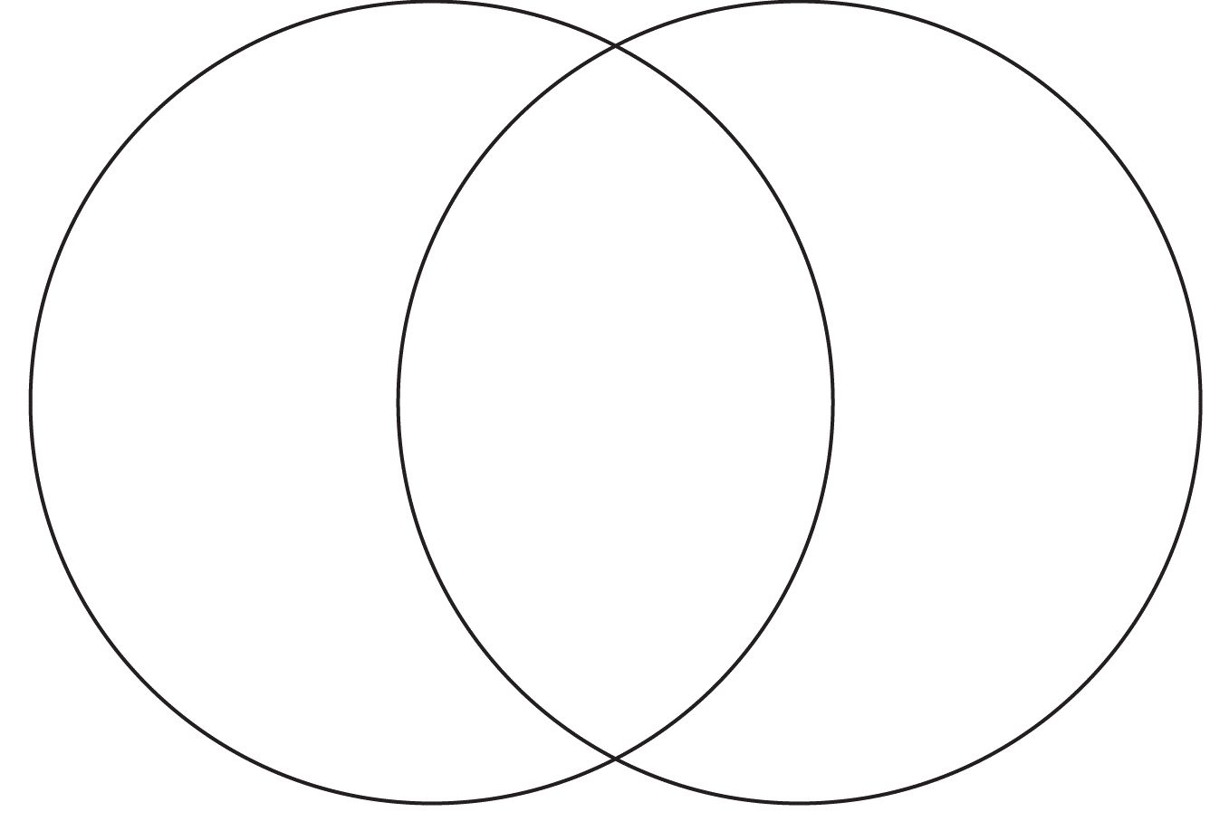

What factor(s) affected Kevin Durant’s healing process?

______________________________________________________________________________
_______________________________________________________________________________

