SPORTS PSYCHOLOGY

Sports Psychology:
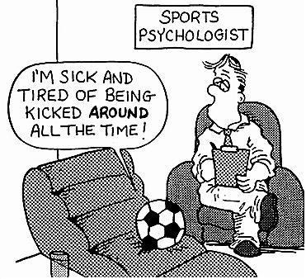

Sports Psychologist:

Depression:

Definition-

Causes-

Signs and Symptoms-

Post- Traumatic Response:

Definition-

Signs and Symptoms-

Stages Athlete May Experience when Injured
1.
2.
3.
4.
5.

Coping With Injury

1.

2.

3.

